## 

**Semester One Examination, 2015**

**Question/Answer Booklet**

## CHEMISTRY

**Stage 3A/B**

|  |  |  |  |  |  |  |  |  |  |  |
| --- | --- | --- | --- | --- | --- | --- | --- | --- | --- | --- |
| Student Number: In figures |  |  |  |  |  |  |  |  |  |  |

|  |  |  |  |  |  |  |  |  |  |  |  |  |
| --- | --- | --- | --- | --- | --- | --- | --- | --- | --- | --- | --- | --- |
|  | In words |  |  |  |  |  |  |  |  |  |  |  |
|  |  |  |  |  |  |  |  |  |  |  |  |  |

**Time allowed for this paper**

Reading time before commencing work: ten minutes

Working time for paper:  three hours

**Materials required/recommended for this paper**

**To be provided by the supervisor**

This Question/Answer Booklet

Multiple-choice Answer Sheet

***To be provided by the candidate***

Standard Items: pens (blue/black preferred), pencils (including coloured), sharpener,

correction fluid/tap, eraser, ruler, highlighters

Special Items:  non-programmable calculators approved for use in the WACE

examinations

**Important note to candidates**

No other items may be taken into the examination room. It is **your** responsibility to ensure that you do not have any unauthorised notes or other items of a non‑personal nature in the examination room. If you have any unauthorised material with you, hand it to the supervisor **before** reading any further.

**Structure of this paper**

|  |  |  |  |  |
| --- | --- | --- | --- | --- |
| **Section** | **No. of Questions Set** | **No. of Questions to be Attempted** | **Marks Allocated** | **Recommended Time (approx) in Minutes** |
| Section1:  Multiple-choice | 25 | 25 | 25 (25%) | 50 |
| Section 2:  Short answers | 9 | 9 | 35 (35%) | 60 |
| Section 3:  Extended answer | 4 | 4 | 40 (40%) | 70 |

**Total Marks for Paper = 100 (100%)**

**Instructions to candidates**

1. The rules for the conduct of Western Australian external examinations are detailed in the *Year 12 Information Handbook 2015*. Sitting this examination implies that you agree to abide by these rules.
2. Answer the questions according to the following instructions.

**Section One -** Answer on the separate Multiple-choice Answer Sheet.

**Section Two -** Answer in this Question/Answer Booklet. Write your answers in the spaces provided, using a blue or black ballpoint or ink pen. Draw any diagrams in pencil. Additional working space and a spare graph is available at the end of this booklet.

**Section Three -** Answer in the lined pages provided in the rear of this booklet

Make sure your School Curriculum and Standards Authority Student Number is on your Multiple Choice Answer Sheet and this Question/Answer Booklet.

1. You must be careful to confine your responses to the specific questions asked and to follow any instructions that are specific to a particular question.
2. Spare pages are included at the end of this booklet. They can be used for planning your responses and/or as additional space if required to continue an answer.

* Planning: If you use the spare pages for planning, indicate this clearly at the top of the page.
* Continuing an answer: If you need to use the space to continue an answer, indicate in the original answer space where the answer is continued, i.e. give the page number. Fill in the number of the question(s) that you are continuing to answer at the top of the page.

**Chemical Equations**

For full marks, chemical equations should refer only to those species consumed in the reaction and the new species produced. These species may be **ions** [for example Ag+(aq)], **molecules** [for example NH3(g), NH3(aq), CH3COOH(aq)] or **solids** [for example BaSO4(s), Cu(s), Na2CO3(s)]. Phases MUST be shown in the equations for the first question of the short answer section.

**Section One: Multiple-choice 25% (25 Marks)**

This section has **25** questions. Answer **all** questions on the separate Multiple-choice Answer Sheet provided. For each question place a cross in the box to indicate your answer. Use only a blue or black pen to cross the boxes. If you make a mistake, circle the incorrect answer and place a cross in a new box.

Suggested working time: 50 minutes.

1. What is the formula of an ionic compound consisting of positive ions with an electron configuration 2, 8, 8 and negative ions with the same configuration?

A. KCℓ

B. MgS

C. NaF

D. LiF

2. Which of the following elemental properties do not have an increasing trend from left to right across Period 3 of the Periodic Table?

1. Atomic number
2. Atomic size
3. Electronegativity
4. Ionization energy
5. Melting point

A. III and IV

B. I, III and IV

C. II and V

D. I, II, IV and V

3. Which type of bonding is not present in solid hydrogen chloride?

A. covalent

B. dipole – dipole

C. dispersion force

D. hydrogen bonding

4. Why is the bond between a sulfur atom and an oxygen atom polar?

A. The S atom has a higher positive charge in the nucleus than the O atom.

B. The O atom is more electronegative than the S atom.

C. The S atom is larger than the O atom.

D. The S atom has more electrons than the O atom, so it will be negative

relative to the O atom.

5. Which of the following correctly describes the shape and polarity of the molecule given?

**Molecule Shape Polarity**

A. PBr3 trigonal planar polar

B. CH2F2 tetrahedral polar

C. PBr3 pyramidal non-polar

D. CH2F2 tetrahedral non-polar

6. Which of the following lists contains atoms or molecules that have only dispersion forces as their most significant type of intermolecular force?

A. CH4, N2, SO2, CO2

B. CO2, F2, CO, CH4

C. O2, CS2, CBr4, He

D. Ne, H2O, CS2, CBr4

7. The boiling points of a family of trihalomethanes (CHX3) are listed below.

Tetrafluoromethane CHF3 –89 oC

Tetrachloromethane CHCl3 61 oC

Tetrabromomethane CHBr3 150 oC

Tetraiodomethane CHI3 330 oC

The increase in boiling points moving down the list is due to an increase in the strength of:

A. covalent bonding.

B. dispersion forces.

C. dipole-dipole bonding.

D. hydrogen bonding.

8. Which of the following statements concerning intermolecular forces

is/are correct?

I Dispersion forces exist in all molecular solids.

II All molecules that contain polar bonds are polar molecules.

III Hydrogen bonding only occurs for molecules containing O-H bonds.

A. I only

B. II only

C. III only

D. I and II only

9. Which of the following statements regarding electronegativity are **true**?

(i) Electronegativity increases across the periods

(ii) Electronegativity increases down the groups

(iii) Fluorine is the most electronegative element

(iv) Electronegativity is a measure of an atom’s power to attract an electron

(v) Group 18 elements are the most electronegative elements

A. (i) and (v) only

B. (i), (ii) and (v) only

C. (i) and (iv) only

D. (i), (iii) and (iv) only

► Questions 10 and 11 refer to the ionisation energy information in the table below:

|  |  |  |  |  |  |
| --- | --- | --- | --- | --- | --- |
| Atom | Ionisation energy (kJ mol-1) | | | | |
| First | Second | Third | Fourth | Fifth |
| W | 738 | 1451 | 7733 | 10543 | 13630 |
| X | 786 | 1577 | 3228 | 4352 | 16100 |
| Y | 419 | 3052 | 4420 | 5877 | 7975 |
| Z | 590 | 1145 | 4912 | 6491 | 8153 |

10. Which atom is most likely to be an alkali metal?

A. W

B. X

C. Y

D. Z

11. If the atoms in the table above were to each react with chlorine, which of the following compounds is least likely to form?

A. WCl3

B. ZCl2

C. XCl4

D. YCl

12. This question refers to the following chemical species:

I : CCl4

II : CH3CH2CH2CH2OH

III: NaCl

IV: CH3CH2COOH

The correct sequence for increasing solubility in petrol (a mixture of octane and heptane) is:

A. I, II, IV and III.

B. III, IV, II and I.

C. III, II, IV and I.

D. IV, II, III and I.

13. The structural formula for cyclopentane is given below.

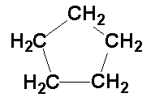

Which of the following compounds is an isomer of cyclopentane?

A. 2 - methylbutane.

B. 2 - pentene.

C. 2 - pentane

D. 2,3 - dimethylpropane.

14. Three organic liquids, (I, II and III) were reacted with sodium, bromine water (bromine dissolved in H2O) and acidified potassium dichromate. The results are listed in the table below.

|  |  |  |  |
| --- | --- | --- | --- |
| Liquid | Sodium | Bromine water (Br2(l)) | Potassium dichromate |
| I  II  III | no reaction  gas evolved  gas evolved | no reaction  no reaction  decolourised | decolourised  decolourised  no reaction |

Which of the following compounds could be liquid III?

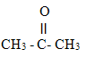

A.



B.



C.



D.

15. Synthetic detergents are more soluble than soap and are more effective in hard water.

Which one of the following compounds is an example of a synthetic detergent?

A. CH3(CH2)10CH2OSO3- Na+.

B. C3(CH2)10COO- Na+.

C. CH3(CH2)12CH2O- Na+.

D. CH3(CH2)12COOH.

16. The IUPAC name for the structure below is:

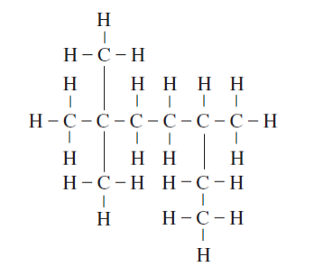

A. 2,2,5-trimethylheptane

B. 3,6,6-trimethylheptane

C. 2-ethyl-5,5-dimethylhexane

D. 5-ethyl-2,2-dimethylhexane

17. Which of the following statements are true about the compound represented by the formula below?

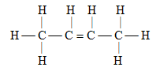

I it decolourises bromine water.

II it is soluble in water.

III it undergoes addition reactions with hydrogen chloride to form two different isomers with the formula C4H9Cl.

IV its systematic name is trans-2-butene.

A. I only.

B. I and III only.

C. I, III and IV only.

D. I, II, III and IV.

*Questions 18 and 19 refer to the following information:*

Sulfur trioxide gas is produced industrially in a reversible reaction involving sulfur dioxide gas and oxygen gas according to the equation:

2SO2 (g) + O2 (g) ⇔ 2SO3 (g)

The reaction to produce sulfur trioxide gas is exothermic.

The equilibrium constant for the reaction as written below at 600oC is 0.471.

2SO3 (g) ⇔ 2SO2 (g) + O2 (g)

18. If the temperature of the equilibrium mixture is decreased to 500oC, the value of the equilibrium constant for the reaction will be

A. less than 0.471.

B. equal to 0.471.

C. greater than 0.471.

D. unable to be determined from the information provided.

19. The equilibrium yield of sulfur trioxide could be increased by

A. increasing the temperature of the equilibrium mixture.

B. using a suitable catalyst.

C. increasing the pressure of the equilibrium mixture.

D. using less oxygen in the equilibrium mixture.

20. This reversible reaction has reached equilibrium.

Co2+(aq) + 6NH3(aq) ⇔ [Co(NH3)6]2+(aq)

A small sample of CoC*l*2(s) was then added. As it dissolved the concentration of Co2+(aq) initially increased. When equilibrium is again established, how will the concentration of all species compare to their concentration prior to addition of *CoCl2*(s)?

Co2+(aq) NH3(aq) [Co(NH3)6]2+(aq)

A. same lower higher

B. higher lower higher

C. higher higher lower

D. lower lower higher

21. Nitrogen dioxide, NO2, (brown) exists in equilibrium with dinitrogen tetroxide, N2O4 , (colourless) in a transparent container whose volume can be adjusted by means of a movable piston. The equation is:

2NO2 ⇔ N2O4

brown colourless

An equilibrium mixture of NO2 and N2O4 is cooled in the container at a fixed volume. As it cools, the brown colour becomes fainter. The equilibrium constant has

A. increased indicating that the reaction is exothermic.

B. decreased indicating that the reaction is exothermic.

C. increased indicating that the reaction is endothermic.

D. decreased indicating that the reaction is endothermic.

22. Consider the following graph:

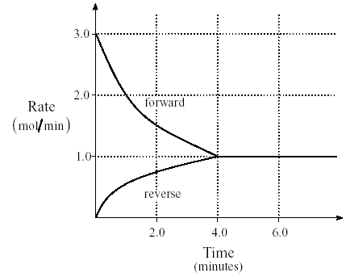

When equilibrium is reached, the rate of the forward reaction is

A. 0.00 mol/min

B. 0.25mol/min

C. 1.0 mol/min

D. 3.0 mol/min

23.Ethene, C2H4, can be produced in the following industrial system:

C2H6 (g) + energy C2H4 (g) + H2 (g)

The conditions that are necessary to maximize the equilibrium yield of C2H4 are

A. low temperature and low pressure.

B. low temperature and high pressure.

C. high temperature and low pressure.

D. high temperature and high pressure.

**The next two items refer to the following information.**

Some of the properties of the pure substances *W, X, Y* and *Z* are given below.

|  |  |  |  |  |
| --- | --- | --- | --- | --- |
|  |  |  | Electrical conductivity | |
| Substance | Hardness  Of solid | Melting Point  (º C) | of solid | of solution |
| W | Soft | -120 | Negligible | High |
| X | Soft | 20 | Negligible | Negligible |
| Y | Hard | 800 | Negligible | High |
| Z | Hard | 2850 | Negligible | Not measured  (insoluble) |

24. The substance most likely to be a covalent network substance is  
  
A. *W*  
B. *X*  
C. *Y*  
D. *Z*

25. The substance most likely to be an ionic network substance is  
  
A. *W*  
B. *X*  
C. *Y*  
D. *Z*

### END OF SECTION ONE

**Section Two: Short answer 35% (35 Marks)**

This section has **nine (9)** questions. Answer **ALL** questions. Write your answers in the spaces provided.

Spare pages are included at the end of this booklet. They can be used for planning your responses and/or as additional space if required to continue an answer.

• Planning: If you use the spare page for planning, indicate this clearly at the top of the page.

* Continuing an answer: If you need to use the space to continue an answer, indicate in the original answer space where the answer is continued, i.e. give the page number. Fill in the number of the question that you are continuing to answer at the top of the page.

Suggested working time: 60 minutes.

1. Draw an electron-dot diagram of the following and state its geometry according to the VSEPR theory:

|  |  |
| --- | --- |
| (a) Nitrate ion (NO3-)  Shape:___________ | (b) Sulphur Dibromide (SBr2)  Shape:___________ |

(3 marks)

2. Explain in a paragraph why an element (Element “A”) with electron structure 2, 8, 2 would have a larger atomic radius than another element (Element “B”) whose electron structure is 2, 8, 5.

|  |
| --- |
|  |
|  |
|  |
|  |
|  |
|  |
|  |
|  |
|  |

(3 marks)

3. This question refers to the following graph that shows the first ionisation energies of a number of elements P, Q, R, S, T, V, W and X.

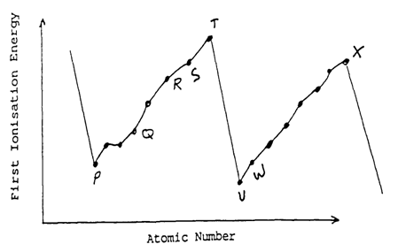

(a) Which pairs of labeled elements are likely to form an ionic compound with each other?

______________________________________________________________

(1 mark)

(b) The compound ST6 has just been made at a research institute in the United States. The conditions for its production were extreme to say the least. Comment on the reasons for the difficulties faced in its production.

|  |
| --- |
|  |
|  |
|  |
|  |
|  |
|  |
|  |
|  |
|  |
|  |

(2 marks)

Another possible compound that may be formed is S2R.

(c) Give **one** likely physical property of this compound.

______________________________________________

(1 mark)

(d) Which element would be the easiest to oxidise?

______________________________________________

(1 mark)

(e) Why is there a rise in the first ionization energy as you go from element P → T on the periodic table?

|  |
| --- |
|  |
|  |
|  |
|  |
|  |
|  |
|  |
|  |
|  |
|  |

(3 marks)

4. Give the correct I.U.P.A.C. name for the following organic molecules:

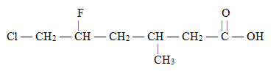

(a)

______________________________________________

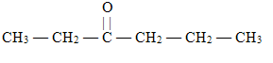

(b)

______________________________________________

(2 marks)

5. The compound below (X) contributes to the ‘leafy’ odour of violet oil.

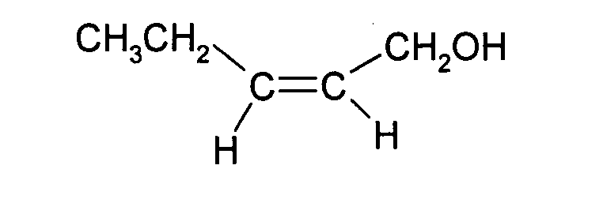

A Chemist reacted compound X with Br2 and produced compound Y.

The Chemist then reacted Y with excess acidified potassium permanganate solution to form compound Z.

(a) Draw the full structural diagram of compound ‘Y’ making sure to show all hydrogen atoms and give the correct I.U.P.A.C. name of the compound.

|  |
| --- |
| Name:__________________________________________ |

(b) Draw the full structural diagram of compound ‘Z’ making sure to show all hydrogen atoms and give the correct I.U.P.A.C. name of the compound.

|  |
| --- |
| Name:___________________________________________ |

(4 marks)

6. For each of the polymer structures shown **draw the monomer or monomers** used in its manufacture and state the polymerization type:

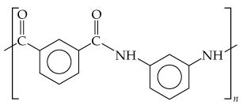 (a)

|  |
| --- |
| Polymerisation Type:_________________________________ |

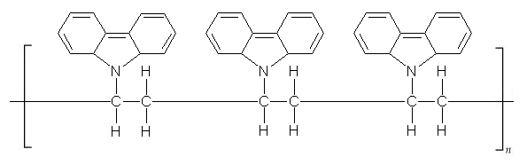

(b)

|  |
| --- |
| Polymerisation Type:_________________________________ |

(4 marks)

7. Quaternary ammonium salts can be represented by the following structural formula.

If the alkyl group (R) is long then the salt acts like a soap or detergent. If it is short the salt has no cleaning properties.

Explain these two differences in properties. Include a labelled diagram.

____________________________________________________________________________________________________________________________________________________________________________________________________________________________________________________________________________________

________________________________________________________________________________________________________________________________________________________________________________________________________________________________________________________________________________________________________________________________________________________________________________________________________________________________________________________________________________________________________________________________________________________________________

(5 marks)

8.The reaction profile diagram below is for the equilibrium reaction of carbon monoxide with nitrogen dioxide to produce carbon dioxide and nitric oxide:

CO(g) + NO2(g) ⇔ CO2(g) + NO(g)

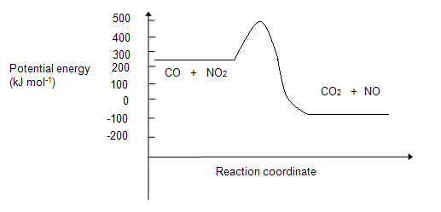

1. What is the value of the activation energy (in kJ.mol-1) for the reverse reaction?

______________________________________________

1. Is the forward reaction as written exothermic or endothermic?

______________________________________________

(c) What change would occur to the shape of this curve if a suitable catalyst was added?

______________________________________________

1. What is the equilibrium law expression (K) for this equilibrium?

|  |
| --- |
|  |

(e) Is it **true** or **false** to say that there will be no change in equilibrium position if the volume of the container is changed?

______________________________________________________________

(f) Is it **true** or **false** to say that there will be no change in the concentration of any of the gases in this equilibrium if volume of the container is changed?

______________________________________________________________

(3 marks)

9. Consider the following reaction:

NaNO3(s) ⇔ Na+(aq) + NO3-(aq)

Given that the reaction is endothermic:

(a) What shift in **equilibrium position** would Le Chatalier’s principle predict if the saturated sodium nitrate solution above is heated.

________________________________________________________

1. Explain in terms of **reaction rates** why this shift occurs.

____________________________________________________________________________________________________________________________________________________________________________________________________________________________________________________________________________________

________________________________________________________________________________________________________________________________________________________________________________________________________________________________________________________________________________________________________________________________________________________________________________________________________________________________________________________________________________________________________________________________________________________________________

______________________________________________________________________________________________________________________________________________________________________________________________________________________________________________________________________________________________________________________________________________________________________________________________________________________________

(3 marks)

**END OF SECTION TWO**

**Section Three: Extended answer 40% (40 Marks)**

This section contains **four (4)** questions. You must answer **ALL** questions. Write your answers in the answer book provided.

Any calculations are to be set out ***in detail*** in the answer booklet provided. You may be penalized significantly for failure to show appropriate working, even if you obtain the correct numerical answer. Marks will be allocated for correct equations and clear setting out of a partial answer, even if you cannot complete the problem.

This part carries **40 marks**.

Numerical answers **MUST** be corrected to **THREE (3) SIGNIFICANT FIGURES**.

Suggested working time: 70 minutes.

1. **Production of benzene** **14 marks**

Benzene (C6H6) can be produced by the dehydrogenation of cyclohexane (C6H12) gas. The reaction has a high activation energy (880 kJ mol−1), is also endothermic and reversible. The cyclohexane (C6H12) passes through a special reaction tower where hydrogen is chemically removed. The benzene/cyclohexane/hydrogen mixture then passes through a compressor, where the benzene is liquefied. A special membrane in the compressor allows the small hydrogen molecules to pass through, and out. The unreacted cyclohexane (C6H12) gas is then returned to the reaction tower.

C6H12 (g) + 120 kJ ⇌ C6H6 (g) + 3 H2 (g)

C6H12

C6H6 + C6H12 + H2

Reaction

tower

Compressor

Unreacted

C6H12

returned

Liquid benzene

C6H6

Hydrogen gas

H2

Hydrogen passes through membrane

a) Draw a labelled energy profile diagram for the reaction.

Potential energy

Reaction progress

(3 marks)

b) Write an equilibrium constant expression for the reaction.

(2 marks)

c) Under what conditions will the rate of the forward reaction be greatest?

________________________________________________________________________________________________________________________________________________________________________________________________________________________________________________________________________________________________________________________________

(3 marks)

d) For a mixture of all three gases at equilibrium in a sealed container, what conditions will produce the maximum yield of benzene?

________________________________________________________________________________________________________________________________________________________________________________________________________________________________________________________________________________________________________________________________

(2 marks)

e) Suggest conditions that would be used for the commercial production of benzene using this process.

Explain, making reference to Le Chatelier’s Principle and Collision Theory why you chose these conditions.

________________________________________________________________________________________________________________________________________________________________________________________________________________________________________________________________

________________________________________________________________________________________________________________________________________________________________________________________________________________________________________________________________________________________________________________________________________________________________________________________________________________________________________________________________________________________________________________________________________________________________________________________________________________________________________________________________________________________________________________________________________________________________________________________________________________________________________________________________________________________________________________________________________________________________________________________________________________________________________________________________________________________________________________________________________________________________________________________________

(4 marks)

**2. 6 Marks**

280.0 mL of hydrogen sulifde gas (H2S) gas at 25**°**C and at 96.0 kPa were bubbled into 155 mL of a 0.206 mol.L-1 lead (II) nitrate solution producing lead (II) sulfide precipitate according to the following equation:

Pb2+(aq) + S2-(aq)­ PbS(s)

Calculate the:

1. Determine the limiting reactant. (Your working must clearly show how you have determine the limiting reactant).
2. Mass of any precipitate formed.
3. Individual concentrations (in mol.L-1) of any ions remaining in the final solution.

*\* Note: The addition of gas does not impact on the solution volume*.

(6 marks)

_____________________________________________________________________________________________________________________________________________________________________________________________________________________________________________________________________________________________________________________________________________________________________________________________________________________________________________________________________________________________________________________________________________________________________________________________________________________________________________________________________________________________________________________________________________________________________________________________________________________________________________________________________________________________________________________________________________________________________________________________________________________________________________________________________________________________________________________________________________________________________________________________________________________________________________________________________________________________________________________________________________________________________________________________________________________________________________________________________________________________________________________________________________________________________________________________________________________________________________________________________________________________________________________________________________________________________________________________________________________________________________________________________________________________________________________________________________________________________________________________________________________________________________________________________________________________________________________________________________________________________________________________________________________________________________________________________________________________________________________________________________________________________________________________________________________________________________________________________________________________________________________________________________________________________________________________________________________________________________________________________________________________________________________________________________________________

____________________________________________________________________

**3. 10 Marks**

An Organic compound is known to contain the elements carbon, hydrogen, nitrogen and oxygen. Combustion of a 6.926g sample of this compound yields 11.82g of carbon dioxide and 5.437g of water, the mixture of nitrogen oxides was not analysed. Another 6.926g sample of the compound was found to contain a percentage mass of Nitrogen of 13.6%

1. Calculate the mass of nitrogen in the 6.926g sample.

________________________________________________________________________________________________________________________________________________________________________________________________________________________________________________________________________________________________________________________________

1. Calculate the empirical formula of the compound.

________________________________________________________________________________________________________________________________________________________________________________________________________________________________________________________________

________________________________________________________________________________________________________________________________________________________________________________________________________________________________________________________________

________________________________________________________________________________________________________________________________________________________________________________________________

________________________________________________________________________________________________________________________________

1. Given that the molecular weight is 103.112 g.mol-1 determine the molecular formula.

____________________________________________________________________________________________________________________________________________________________________________________________________________________________________________________________________

____________________________________________________________

1. Given that the molecule is an alpha-amino acid, give a possible molecular structure.
2. The material produced was found to polymerise with the amino acid glycine, which has the formula shown below. Show two repeating units of the protein that is formed.

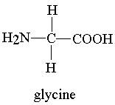

(10 marks)

**4. 10 marks**

Water and kerosene (a mixture of alkanes with 12 to 16 carbon atoms) are two vastly different substances, although they visually appear quite similar. Both are clear, colourless liquids (although Kerosene is often tinted blue as a safety measure), and both are effective solvents in their own right. Given your knowledge of intermolecular forces, solubility, the water molecule and the structure of alkanes answer the questions below.

***NB – It is not enough to just give an observation, you need to provide an explanation as well.***

1. Detail the attractive forces between the water molecules.

|  |
| --- |
|  |
|  |
|  |
|  |
|  |
|  |
|  |
|  |

(2 marks)

1. Detail the attractive forces between kerosene molecules.

|  |
| --- |
|  |
|  |
|  |
|  |
|  |
|  |
|  |
|  |

(2 marks)

1. What is the solubility of water in kerosene? – explain.

|  |
| --- |
|  |
|  |
|  |
|  |
|  |
|  |
|  |
|  |

(2 marks)

1. Would ionic solutes, such as NaCl dissolve in water? - explain.

|  |
| --- |
|  |
|  |
|  |
|  |
|  |
|  |
|  |
|  |

(2 marks)

1. Would ionic solutes such as NaCl dissolve in kerosene? – explain.

|  |
| --- |
|  |
|  |
|  |
|  |
|  |
|  |
|  |
|  |

(2 marks)

**END OF SECTION THREE**

|  |
| --- |
| Additional Working Space |
|  |
|  |
|  |
|  |
|  |
|  |
|  |
|  |
|  |
|  |
|  |
|  |
|  |
|  |
|  |
|  |
|  |
|  |
|  |
|  |
|  |
|  |
|  |
|  |
|  |
|  |
|  |
|  |
|  |
|  |
|  |
|  |
|  |
|  |
|  |
|  |
|  |
|  |
|  |
|  |
|  |
|  |
|  |
|  |
|  |
|  |
|  |
|  |
|  |
|  |
|  |
|  |
|  |
|  |
|  |
|  |

**END OF PAPER**